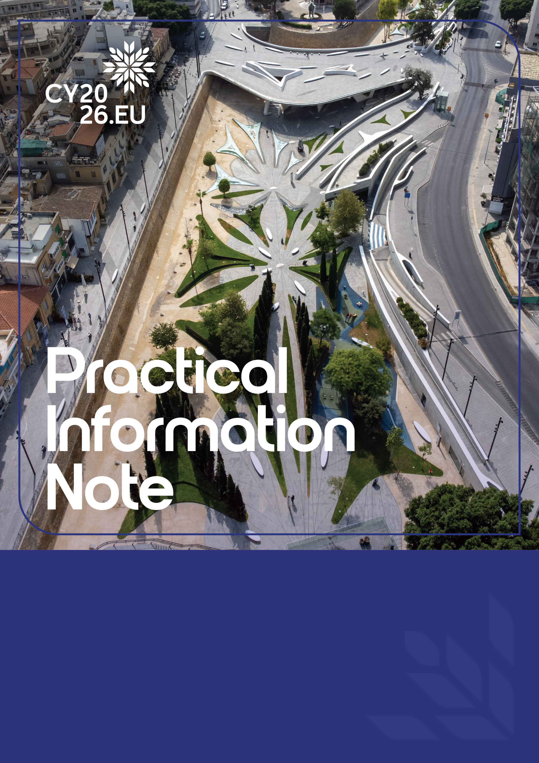

INFORMAL MEETING OF EMPLOYMENT & SOCIAL AFFAIRS MINISTERS(EPSCO)

LEFKOSIA (NICOSIA), CYPRUS
12-13 February 2026

LIST OF CONTENTS

KEY DEADLINES 3
LOCATION AND VENUES 4
DELEGATIONS, REGISTRATION AND ACCREDITATION 6
Delegation format 6
Registration & Accreditation 6
Delegation Accreditation Officer (DAO) 6
Pins and badges 7
SECURITY 8
Weapon permits 9
Radio and communication frequencies 9
PRELIMINARY PROGRAMME 10
BILATERAL MEETING ROOMS 11
INTERPRETATION 12
TRANSPORT 12
Points of entry 12
Arrivals and departures 12
Transportation 13
ACCOMMODATION 14
HEALTHCARE ARRANGEMENTS 14
SUSTAINABILITY 15
MEDIA 15
THE PRESIDENCY ONLINE 15
OTHER PRACTICAL INFORMATION 16
CONTACT DETAILS 16

GENERAL INFORMATION

The Cyprus Presidency of the Council of the European Union 2026 has the pleasure of welcoming you to Lefkosia (Nicosia) for the Informal Meeting of Employment & Social Affairs Ministers, which will take place on the 12th and 13th of February 2026, at the Filoxenia Conference Centre.

This Practical Information Note (PIN) is intended to provide all necessary logistical and programme-related information to facilitate the preparation of your visit.

Please note that the information contained herein may be subject to change. The Cyprus Presidency will share any updated information related to the meeting through the Cyprus Presidency’s dedicated Accreditation Platform.

KEY DEADLINES

When | What | Where/Who
13-20/01/2026 | Appoint a Delegation Accreditation Officer (DAO) | informalepscoes@cyprus2026eu.gov.cy
13/01/2026 | Accreditation platform opens | accreditation@cyprus2026eu.gov.cy
30/01/2026 | Deadline for claiming pre-booked hotel reservations | Delegations to indicate booked rooms through the Accreditation Platform
02/02/2026 | Accreditation platform closes | Accreditation Team
13/02/2026 | Informal EPSCO (Employment & Social Affairs) | Filoxenia Conference Centre

LOCATION AND VENUES

Location

Lefkosia (Nicosia)
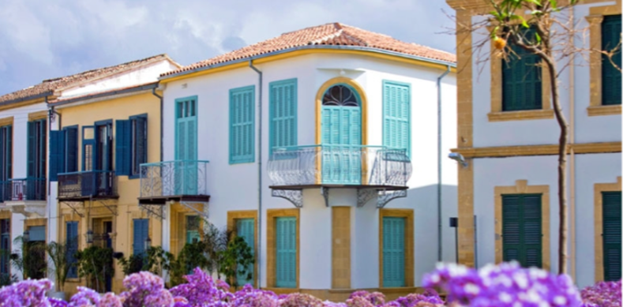

Photo from: Visit Cyprus
Lefkosia (Nicosia) – the last divided capital of Europe, as part of it remains under illegal military occupation by Turkey – is a city where centuries of history meet a vibrant, cosmopolitan present. As the island’s administrative and business centre, it combines the energy of a modern European capital with the timeless charm of an ancient walled city.

At its heart lies the old town, encircled by impressive Venetian walls and heart-shaped bastions, offering a glimpse into the city’s medieval past. Narrow streets, traditional shops, and historic monuments sit alongside contemporary galleries, museums and cultural venues, reflecting Lefkosia’s dynamic character.

The modern city beyond the walls is fast-paced and forward-looking, home to major commercial and financial institutions. Its retail landscape spans from bustling shopping districts and malls to artisan quarters filled with local crafts. A diverse culinary scene and a vibrant nightlife, where cafés and bars coexist with centuries-old buildings, contribute to the city’s unique blend of old and new.

Beyond the urban centre, the wider Lefkosia region reveals a more peaceful side. Picturesque countryside and mountain villages offer opportunities for hiking, cycling and exploring traditional life in scenic surroundings. Stone-built homes, quiet trails and welcoming village squares invite visitors to experience the region’s rural charm.

With its many layers of history, culture and modern life, Lefkosia stands as the beating heart of Cyprus – a capital that bridges the past and the future.

Discover more about Lefkosia – Visit Lefkosia

Venue
Filoxenia Conference Centre
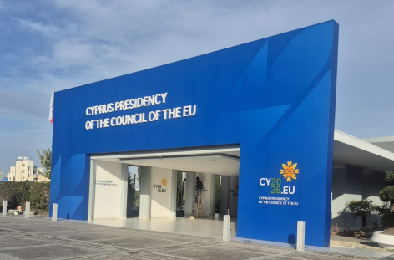

17 Thrakis Street, Aglantzia 2112, Nicosia, Cyprus

Built in 1990, Filoxenia Conference Centre is the main conference venue of Lefkosia and a landmark for international events in Cyprus. During the first Cyprus Presidency of the European Union in 2012, the Filoxenia Conference Centre served as the primary conference venue and will be the main venue for most high-level and working-level meetings during the Cyprus Presidency of the Council of the European Union 2026.

The venue has been renovated to align with sustainable development standards and environmental best practices, offering a modern and eco-friendly setting for participants. It features state-of-the-art electronic infrastructure with high-speed Wi-Fi, interpretation booths, lounge and restaurant areas for delegations, bilateral meeting rooms and other essential facilities.

Access to the Filoxenia Conference Centre is carefully managed, with a main entrance for delegates and a separate entrance to the Media Centre, while only police-escorted vehicles are permitted to enter the premises.

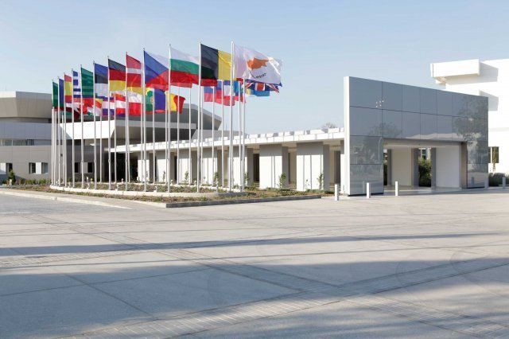
Security will be of the highest standard, including x-ray screening, CCTV monitoring, controlled access points, safety barriers, 24-hour surveillance, cybersecurity safeguards and a continuous police presence on site.

DELEGATIONS, REGISTRATION AND ACCREDITATION

Delegation format

Participation in the Informal EPSCO (Employment & Social Policy Meeting) will follow the 1+2 format, referring to one (1) Head of Delegation and 2 accompanying delegates.

Registration & Accreditation

To ensure secure and efficient access to the meeting venue, delegation members must be registered and accredited in advance through the Cyprus Presidency’s dedicated online Accreditation Platform.

For security reasons, access to the venue and other official parts of the programme will be granted exclusively to accredited members of the delegation.

Registration and accreditation will be managed centrally by the designated Delegation Accreditation Officer (DAO) through the Cyprus Presidency’s dedicated online Accreditation Platform. The DAO will complete the required procedures on behalf of all delegation members within the established deadlines.

All personal data provided for accreditation will be processed in full compliance with the EU General Data Protection Regulation (GDPR). The Cyprus Presidency’s personal data privacy notice can be accessed through the Accreditation Platform.

For any questions related to registration and accreditation, please do not hesitate to contact the Accreditation Team (contact details are provided in the last section).

Delegation Accreditation Officer (DAO)
The designated DAO will serve as the exclusive point of contact with the Cyprus Presidency on all matters regarding registration and accreditation.

To appoint the DAO, please submit their full name, telephone number and email address to informalepscoes@cyprus2026eu.gov.cy no later than 20/01/2026. Once appointed, the DAO will receive login credentials and detailed guidance for using the Accreditation Platform.

The Cyprus Presidency’s dedicated Accreditation Platform will be used to manage all relevant delegation information, including personal details, accreditation, transportation arrangements as well as accommodation and dietary requirements.

It is the DAO’s responsibility to ensure that all members of the delegation are duly registered and that all required information is submitted accurately by 02/02/2026. By centralising this process, the Cyprus Presidency aims to guarantee smooth coordination and to facilitate the full and secure participation of each delegation in the meeting.

Following registration, the platform will remain accessible until three days prior to the commencement of the event, allowing delegations to enter their flight numbers and hotel accommodation details. Please note that once the registration period has closed, only the sections pertaining to flight details and hotel accommodation will remain available for editing.

Pins and badges

Upon arrival at Larnaka or Pafos International Airports, the Head of Delegation (HoD) will receive a pin and delegation members will receive badges.

The distribution of the pin for the HoD and the badge for one (1) accompanying delegate will take place through each delegation’s designated Liaison Officer. The distribution of badges for the remaining accredited delegates will take place at the Cyprus Presidency’s Information Points at Larnaka and Pafos International Airports.

Delegates arriving two days before the meeting or earlier are requested to collect their badge at the Late Accreditation Centre, which will operate outside the Filoxenia Conference Centre in Lefkosia.

All pins and badges are strictly personal and non-transferable and must be visible at all times within the official venue, designated means of transport and security areas and, generally, throughout all parts of the official programme.

Lost pins or badges should be reported immediately to the Accreditation Team via the contact details provided in the last section.

LIAISON OFFICERS

Each delegation will be assigned Liaison Officers (LOs) by the Cyprus Presidency of the Council of the EU.

Under the guidance of coordinators, the LOs will serve as the main contact persons, delivering logistical support and assistance throughout the programme. Key responsibilities include:
• Distributing pins and badges
• Providing assistance at the venues and support throughout the programme
• Escorting the delegation to the airport for departure

Moreover, additional Liaison Officers will be present at the two Cyprus Presidency’s Information Points at Larnaka and Pafos International Airports, at the meeting venue and the designated hotel as well as in the official transportation vehicles.

Contact details of the assigned LOs will be provided to each delegation through their Diplomatic Mission in Cyprus well ahead of the meeting.

SECURITY

Security during the meeting will be ensured by the Cyprus Police, in close cooperation with all relevant national authorities.

Each delegation can accredit up to one (1) security officer via the Cyprus Presidency’s dedicated Accreditation Platform.

Designated security zones and transportation vehicles will be accessible only to duly accredited members of the delegation wearing visibly valid badges at all times.

Every person entering the Filoxenia Conference Centre will be subject to mandatory security screening at each entry, including walk-through metal detector checks and X-ray screening of personal belongings and electronic devices.

Weapon permits

Diplomatic Missions are required to follow the standard application procedure to obtain the necessary permits. In addition to this procedure, if a security officer of a Head of Delegation carries a weapon, this must also be disclosed through the Cyprus Presidency’s dedicated Accreditation Platform.

Obtained weapon clearance (original document) must be presented upon arrival. Request shall be filed 10 days prior to planned visit to the Republic of Cyprus at the latest. In the note verbale, it is necessary to provide the following information for each individual security officer:
- Security officer’s name and rank
- Arrival/departure date and time
- Means of transportation to/from Cyprus
- Date and place of birth
- Passport number and expiry date
- Weapons (serial number, type, calibre, number of ammunitions)

Radio and communication frequencies

Use of radios/walkie-talkies is permitted only through the standard procedure, in order to prevent interference with Cyprus Police communication frequencies.

An official request must be submitted to the Protocol Department of the Ministry of Foreign Affairs to grant permission for radio frequencies for the purpose of communication between security officers of a foreign delegation.

Request shall be filed 10 days prior to planned visit to Cyprus at the latest. Note verbale should include:
- Information about radio equipment
- Indicated radio frequency needed for communication

PRELIMINARY PROGRAMME

Please note that this programme is subject to change.

The final detailed programme and accompanying steering notes will be shared with participants in advance of the meeting.

Thursday 12 February

18.30 – 19.15 Transfer from the hotels to the Dinner Venue
*Transfer for those staying in Larnaka will start at 18:30, and for those staying in Nicosia, transfer will start at 19:00
19:15 – 20.00 Welcome Drink and Cultural Event
20.00 – 22.00 Gala Dinner
22.00 Transfer to the Hotels

Friday 13 February

08.00 – 08.15 Transfer to the Conference Venue
*Transfer for those staying in Larnaka will start at 07:15, and for those staying in Nicosia, transfer will start at 07:45
08.15 – 08.45 Arrival at the Conference Venue
Handshake and opportunity of doorstep interviews

09.00 – 11.00 Opening Plenary Session I (format 1+2)
Topic: Fair Employment for Social Justice
09.00 – 10.00 Introductory Statements
10.00 – 11.00 Interventions

11.00 – 11.20 Coffee Break
11.20 – 12.50 Continued Plenary Session I
Interventions

12.50 – 13.00 Family Photo

13.00 – 14.00 Lunch
14.00 – 15.30 Plenary Session II
Topic: European Anti-Poverty Strategy

15.30 – 15.50 Coffee Break
15.50 – 17.30 Plenary Session III
Topic: Person-Centered Long-Term Care as a Driver of Active Ageing

17.30 – 18.00 Press Conference
18.00 Transfer from the Conference venue to hotels / airport

BILATERAL MEETING ROOMS

Bilateral meeting rooms at the Filoxenia Conference Centre will be available upon request by the delegation. These can be reserved in advance or on the day of the meeting by contacting the assigned Liaison Officer.

Meeting rooms are reserved in 30 minutes slots. Interpretation will not be provided for bilateral meetings.

The following information shall be indicated when booking bilateral meeting rooms:
- Name of the meeting
- The counterpart
- The preferred date and time
- Number of participants

INTERPRETATION

Simultaneous interpretation for the meeting at the Filoxenia Conference Centre will be provided by the European Commission’s Directorate General for Interpretation (DG SCIC) in a 6/6 language regime (EL/EN/FR/DE/ES/IT).
The press conference will be held in Greek and English.

If additional interpretation is required beyond the official provision, delegations may bring their own interpreter. In this case, the interpreter must be accredited in advance via the Cyprus Presidency’s dedicated Accreditation Platform and will count as one (1) of the 2 allocated delegation members.

TRANSPORT

Points of entry

Note: The legal points of entry by air into the Republic of Cyprus are the International Airports of Larnaka and Pafos. There are no legal points of entry in the occupied areas of the Republic of Cyprus, where the Government of the Republic of Cyprus does not exercise effective control due to the Turkish occupation. Entering through any airport or port in the occupied areas of the Republic of Cyprus is illegal.

For further information on the legal points of entry into the Republic of Cyprus, consult the website of the Ministry of Foreign Affairs of the Republic of Cyprus: https://www.gov.cy/mfa/en/documents/important-information-concerning-travel-to-the-turkish-occupied-area-of-cyprus/

Arrivals and departures

Heads of Delegation, together with one (1) accompanying delegate, will be received by a Protocol Officer from the competent Ministry as well as a Liaison Officer at the “Heads of State Terminal” at Larnaka International Airport.

Please note that only one (1) embassy vehicle may join the official motorcade, but only if it is cleared by the Cyprus Police (Emergency Response Unit) from departure to the final destination and vice versa. Kindly note also that once the embassy vehicle exits the motorcade at any point, it will not be permitted to re-enter the motorcade.

Additional members of the delegation travelling with or separately from the Head of Delegation are required to follow standard arrival procedures and are responsible for handling their own luggage.

Upon arrival at Larnaka International Airport, delegates should first proceed to the Cyprus Presidency Information Point located after passport control, where accreditation badges will be available for collection. Immediately after customs clearance, delegates will reach the second Information Point, where they will receive assistance with their transfer to the designated hotels.

At Pafos International Airport, the Cyprus Presidency Information Point will be available after arrivals, just before customs clearance in the arrivals area. Delegates can collect both their accreditation badges and receive assistance regarding transfers to the designated hotels.

Delegates who wish to make use of the transportation offered by the Cyprus Presidency are requested to indicate this through the Accreditation Platform, where they will need to provide full travel details (e.g. flight number, arrival / departure time, etc.) at least 3 days before the start of the meeting. Transportation from and to the airport cannot be provided by the Cyprus Presidency without the provision of these details, due to practical reasons.

Please note that a waiting time at the airport of up to two hours may be required. Alternative means of transportation, such as taxi services, shuttle services and public transportation are available at the airport premises and must be arranged individually.

Delegates wishing to proceed directly to the airport from the meeting venue at the end of the programme, or earlier, are requested to indicate this via the Accreditation Platform.

Please note that transfers from and to the airport will be available from the day before the meeting until the day after the meeting. In case of earlier arrival or later departure, delegates will have to make and cover their own transportation arrangements.

Transportation

The Cyprus Presidency will provide transport for members of the official delegation. Transfers will operate between airports, designated hotels as well as the meeting venues throughout the official programme, in coordination with the Cyprus Police.

Please note that only VIP vehicles within the motorcade will be permitted to enter the premises of the Filoxenia Conference Centre.

Transport to events or meetings that are not included in the aforementioned official programme will not be provided by the Cyprus Presidency.

ACCOMMODATION

Hotel rooms for this meeting have been pre-booked by the Cyprus Presidency for all delegates at Ηilton Nicosia and Radisson Blu Larnaka.

For the Head of Delegation and the one (1) additional delegate, the accommodation is covered by the Cyprus Presidency for 12/02/2026 (one room on a bed and breakfast basis). The reservation will be made by the Cyprus Presidency upon registration. After the completion of registration, a message will be sent with the reservation details.

Other delegates who intend to make use of the pre-booked rooms are requested to follow the booking process via the link on the Accreditation Platform. Please note that delegates are responsible for making their own reservations and for covering accommodation costs.

Delegates staying at another hotel, other than the one pre-booked by the Cyprus Presidency, are kindly requested to specify the hotel name on the Accreditation Platform under the section “Other”.

HEALTHCARE ARRANGEMENTS

The venue will have a fully equipped healthcare point with medical assistance.
The hospital in Cyprus that will be on hospital alert during the meeting is the Lefkosia General Hospital.

At the time of accreditation, the platform will ask for relevant information on allergies, dietary restrictions and preferences of the delegation and voluntarily: blood group, mobility issues, medicinal allergies and pharmaceutical treatments. It is important that all this information is provided so that they may be addressed properly. Please note that this information will be kept strictly confidential. Safeguarding the health of participants is a priority.

SUSTAINABILITY

The Cyprus Presidency aims to ensure that environmentally, socially and economically responsible choices are made throughout its planning and execution.

MEDIA

The Cyprus Broadcasting Corporation (CyBC) has been designated as the Host Broadcaster of the Cyprus Presidency of the Council of the EU 2026 and will provide audiovisual coverage of the meeting:
- Arrival and doorstep
- Handshake
- Family photo
- Press conference

The Press and Information Office (PIO) will serve as the Host Photographer of the Cyprus Presidency of the Council of the EU 2026.

A Media Guide, prepared by the Communication Team of the Cyprus Presidency, will be uploaded to the Cyprus Presidency’s website.

THE PRESIDENCY ONLINE

The website and Social Media channels of the Cyprus Presidency of the Council of the EU 2026 are the Presidency’s main communication channels, where news, events and other official material are published.

- Website:
Cyprus Presidency of the Council of the EU 2026

- Social Media Channels:
- Instagram: @cy2026eu
- Facebook: facebook.com/CY2026EU
- LinkedIn: Cyprus Presidency of the Council of the EU 2026

- YouTube: https://www.youtube.com/@cy2026eu
- X: @cy2026eu
- BlueSky: @cy2026eu.bsky.social
- Flickr: Cy2026.EU

OTHER PRACTICAL INFORMATION

Emergency number: 112 (fire brigade, ambulance, police)

Electricity: The voltage in Cyprus is 230V. Cyprus uses Type G plugs (UK-style with three rectangular pins), so bringing a suitable plug adapter, if needed, is advisable

Local time zone: Eastern European Time (EET) (GMT +2)

Country code: Cyprus +357

Currency: The official currency of Cyprus is Euro (€)

Weather: Weather in Cyprus

Smoking: Smoking is only allowed outdoors in the designated areas of the official meeting venues

CONTACT DETAILS

For information on the preliminary programme:
- Email: informalepscoes@cyprus2026eu.gov.cy
- Phone number: +357 22401749 / 22401696

For information on registration and accreditation:
- Email: accreditation@cyprus2026eu.gov.cy
- Phone number: +357 22801765

For information on accommodation:
- Email: hospitality@cyprus2026eu.gov.cy
- Phone number: +357 22308325

For information on transportation:
- Email: transportation@cyprus2026eu.gov.cy
- Phone number: +357 22801835

For information on Liaison Officers:
- Email: liaison@cyprus2026eu.gov.cy
- Phone number: +357 22801845

